Dear Musicians,
Thank you for registering for World String’s Day on 29th July 2023. We are excited to have you as a part of this event.

Please take note of the time and location:
29th July, Saturday
The South Beach
26 Beach Rd, Singapore 189768

Registration starts @ 4.30pm
There will be a registration counter here:
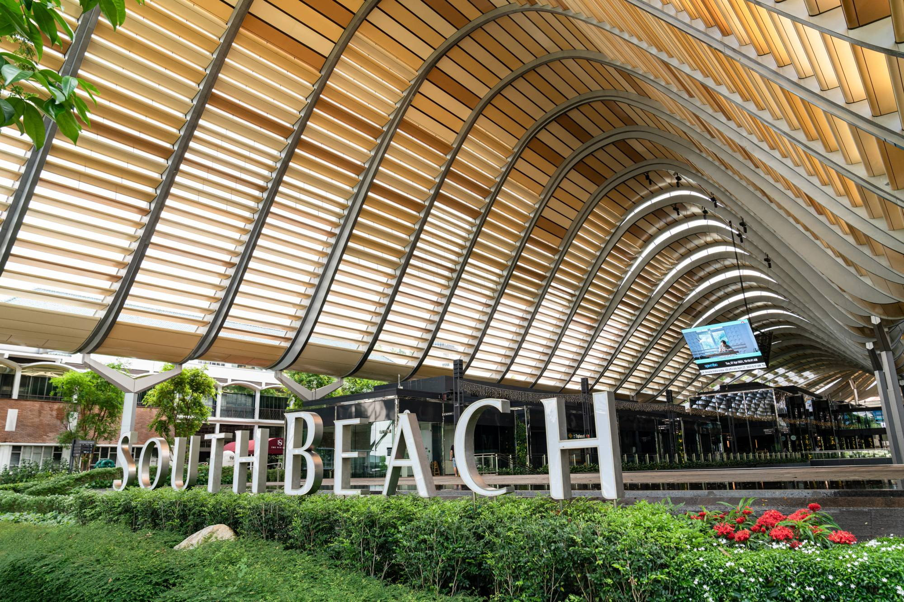

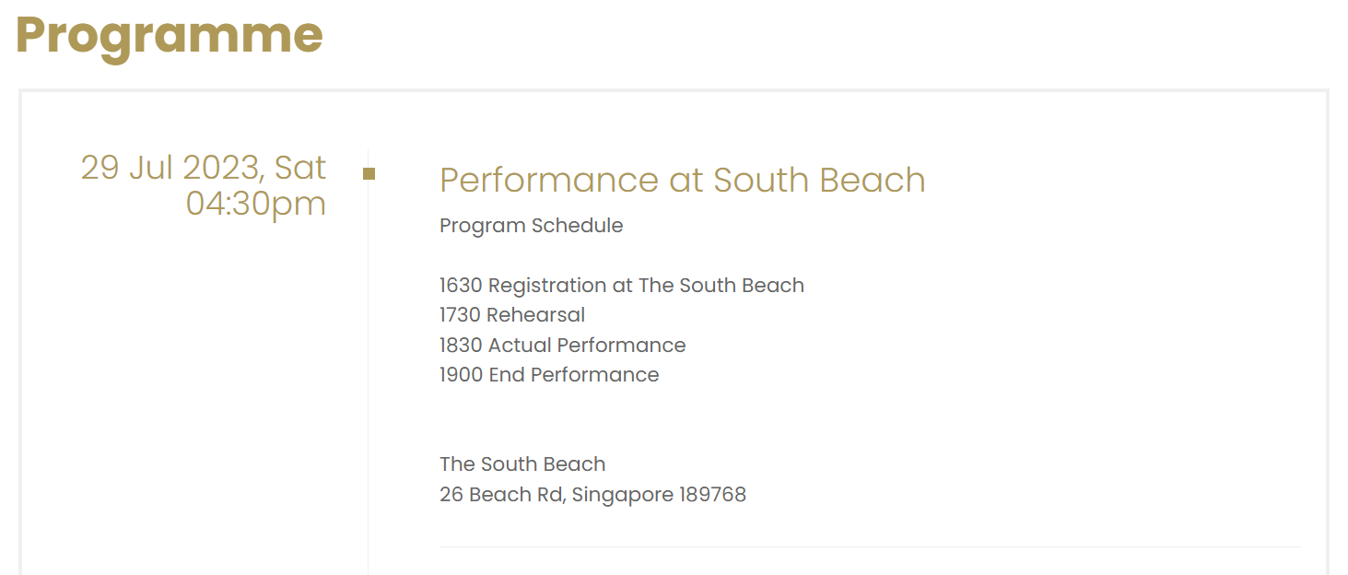

- Registration starts @ 4.30pm
- Prepare your instrument, bow, music score, music stand, and fully attired (refer to dress code)
- Belongings to be taken care of respectively*
- To be in position on stage before 5.30pm rehearsal

*For the storage arrangement of personal belongings and instruments cases, there will be a holding area only for individuals and cellists.
**For participants that come to the event with family or friends, we kindly request that you entrust your belongings and cases to them instead of using the holding area.

What do I need to bring:
1. Instrument
2. Music Stand (Log in to GSF to download)
3. 3 Music scores with folders/clips (the 3 pieces to be performed)

Dress Code: (There will be no WSD T-shirts collection)
- WSD T-shirt
- Dark coloured long pants
- Covered shoes

*It will be mass performance open to public – family and friends are invited to watch.
*There will be no roadblock to South Beach.

For any enquiries please call: Ginny +65 8920 6689

